Christopher Street Pier

What is a pier?
A pier is a raised structure, including bridge and building supports and walkways, typically supported by widely spread piles or pillars. The lighter structure of a pier allows tides and currents to flow almost unhindered, whereas the more solid foundations of a quay or the closely spaced piles of a wharf can act as a breakwater, and are consequently more liable to silting. Piers can range in size and complexity from a simple lightweight wooden structure to major structures extended over 1600 metres. In American English, pier may be synonymous with dock.

The pier on the Christopher Street
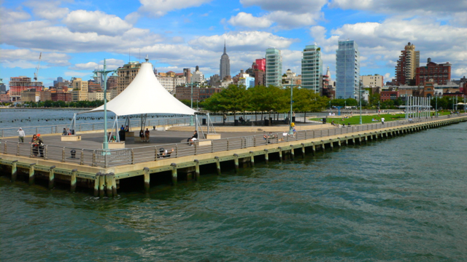

Why people goes there?
It is an peaceful place inside Manhattan

You can take a Water Taxi and See all Manhattan from the water
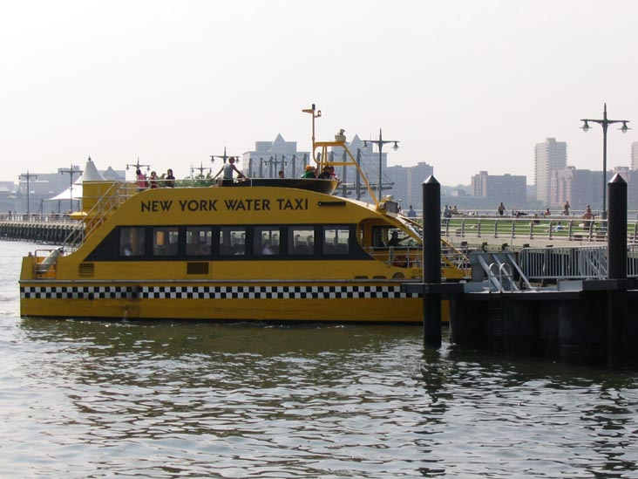
When is summer, you can go there to tan and take some D vitamin
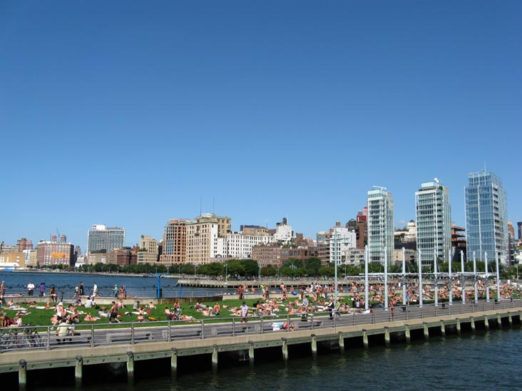
Some girls are used to do topless
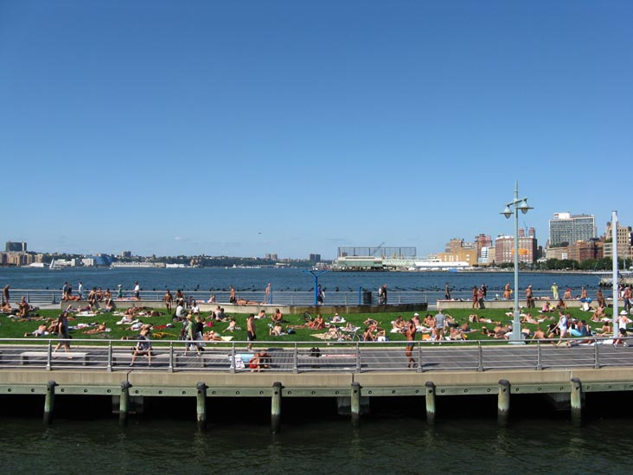

You can sit down and study english
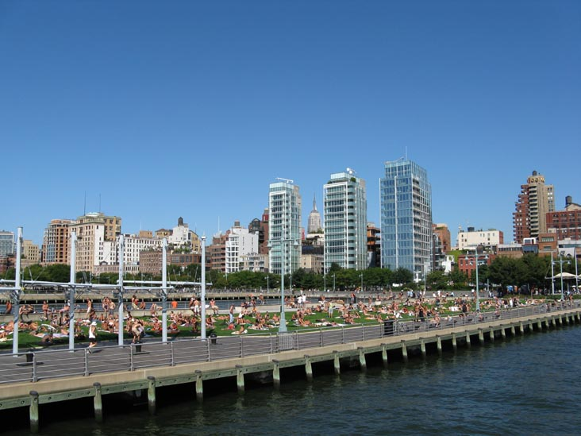

There is a shade if you don’t like the sun
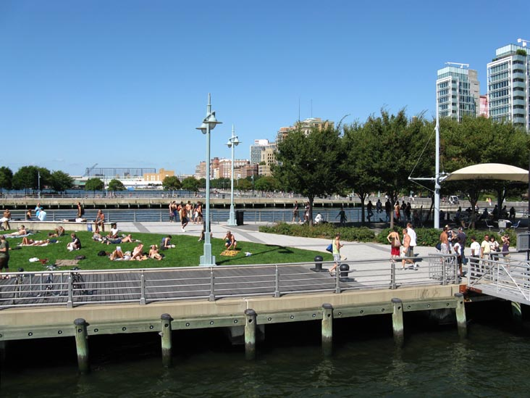
You can see the diversity of New York
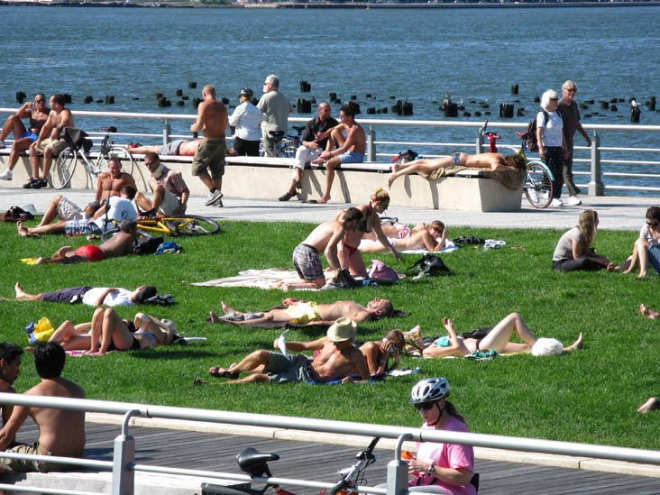
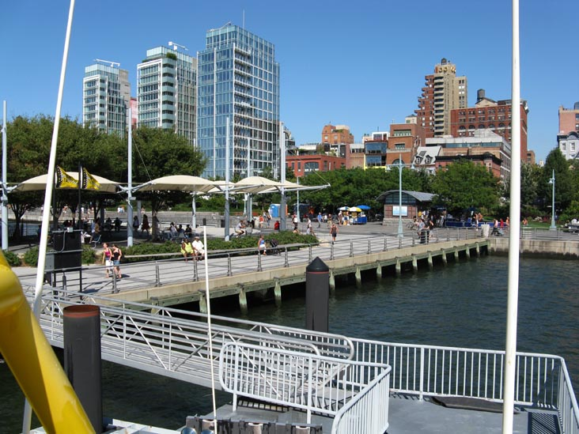
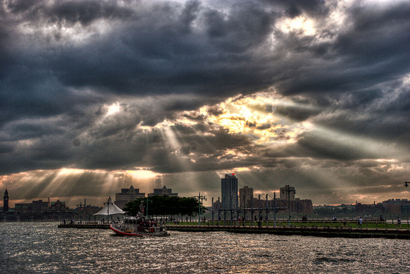
You can have some free classes

It’s a good place to renew our energy

How do you get there?

